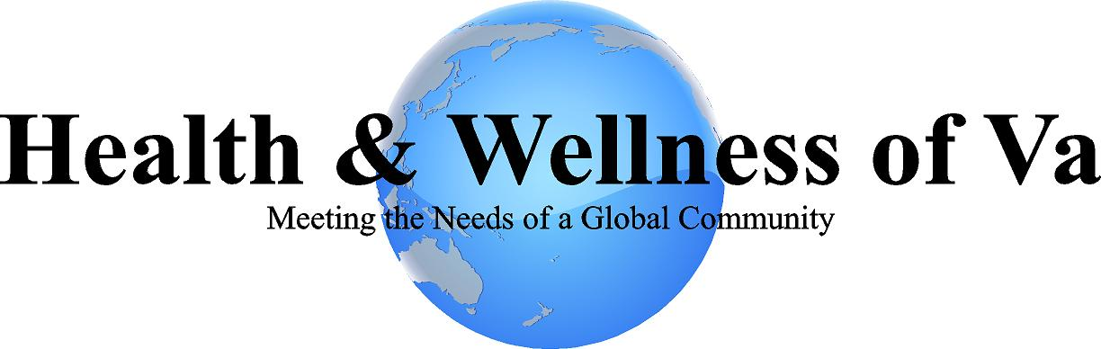

2019-2020

Strategic Business Plan

- PURPOSE

This document comprises a strategic plan for Health &Wellness of VA. It presents a series of fundamental statements relating to Health & Wellness of VA’s mission, values and objectives; reviews its strengths, weaknesses, opportunities and threats; and sets out Health & Wellness of VA’s proposed strategies, goals and action programs.

- MISSION

The mission of H&W Enterprises of NC, LLC DBA Health & Wellness of VA is:

“Empowering individuals and families to seek their own level of wellness by addressing their holistic mental health, addiction, and community support needs.”

- ENVIRONMENTAL SCAN

STRENGTHS
- Committed leadership team and staff
- Financially strong
- Client driven
- Management team is able to multitask
- Located within the service community
- Able to provide an array of services that fit the needs of the persons served
- Ability to community needs/barriers of service gaps
- Good reputation within community and with stakeholders
- Open to new ideas
- Team approach
- Services provided as needed, when needed, 24/7
- A holistic and wellness approach to persons served
- Sustainability of services to persons served
WEAKNESSES
- Our revenue is variable secondary to a complex Medicaid market.
- Multiple competing services have been identified within the area.
- A new streamlined medical record system needs to be identified and obtained for ease of document storage.
- Access to services and billing additional revenue streams have yet to be pursued.
OPPORTUNITIES
- With CARF accreditation, expand to new state funded programs
- Expand services to fill-in program areas that are needed in the community and are not yet provided by our competitors
- Increasing educational opportunities for our staff and partners
- Multiple programs that can be successfully offered and marketed to the community.
THREATS
- Larger agencies may have more capabilities and provide service alternatives
- Reduction in Federal/State funding especially Medicaid funding
- Community sustainability
- Lack of other community resources

- CORPORATE VALUES

Health & Wellness of VA operates in accordance with the highest standards in all relationships with consumers, stakeholders, environment, and the community. The following corporate values are paramount to the success of this agency.

Excellence:
- We are passionate about delivering results.
- We are dedicated to total customer satisfaction.
- We evaluate our efforts and strive to do better.
- We make a positive difference in people's lives.
- We promote individual and agency growth.
Stewardship:
- We are accountable to our customers and our community.
- We manage resources effectively and efficiently.
- We plan today to prepare for tomorrow.
- We maintain financial strength.

Integrity:
- We apply the highest ethical, moral and professional standards in our conduct.
- We work with a passion to do the right thing.
- We care about what we do.

Respect:
- We believe that people are our most valuable assets.

Innovation:
• We constantly look for ways to improve, to be more effective and efficient and to do things better.

Team Work:
- We are a community with diverse strengths working together to achieve a common goal.
- We recognize and respond to the needs of others.
- We are responsible to each other.
- We build on each others strengths.

- BUSINESS OBJECTIVES

- Create a high-quality standard of services for person’s served.
- To build sustainability for Health & Wellness of VA.
- Diversify various funding resources.
- Develop a solid infrastructure for the management team.

- MAJOR GOALS 2019-2021

The following are the key goals for Health & Wellness of VA.

- Achieve CARF accreditation by 2020.
- Further enhance safe guards that help to ensure the integrity of our communications and records.
- Develop an annual financial budget that contains reasonable projections of revenue and expenditures.
- Develop a structured training model that will improve and enhance the efficiency and effectiveness of the services provided to the person’s served.
- Continue to expand available to service to best meet the needs of the community in which we serve.
- Improve design of current website and marketing materials to better reach our target population.
- Seek out improved access to streamlined electronic health records systems to meet the current fast paced documentation demands.

- ACTION PLANS

The following critical strategies will be pursued by Health & Wellness of VA in the pursuit of goal progression.

- TEAMWORK
  - Strategy: Enhance teamwork through increased communication.
    - Action Step:
      - Establish and maintain strong and open relationships with internal and external stakeholders.
      - Improved relations with medical/psychiatric/mental health professionals.
      - Improve communication within Health & Wellness of VA.
        - Success Indicators: Continued increasing levels of referrals, timely communication, improved satisfaction ratings, and increased internal collaboration.
- SERVICE DOCUMENTATION
  - Strategy: Define priorities for the electronic medical record in order to achieve efficiencies, achieve CARF documentation conformance and to simplify data entry.
    - Action Step:
      - Establish written procedures for clinical and financial software for current and new staff.
      - Provide necessary training for all current staff.
      - Identify what is expected to achieve CARF conformance related to clinical documentation.
      - Develop a process to encourage staff input/feedback regarding needed software/documentation improvements.
        - Success Indicators: Continued clinical quality review reports demonstrate improvement in conformance with clinical documentation expectations.
- SERVICE EXPANSION
  - Strategy: Health & Wellness will actively explore service expansion and program development to meet the ongoing needs of the community.
    - Action Step 1:
      - Conduct a review of the current needs of the persons served in order to determine needs that are not currently being adequately addressed.
      - Evaluate funding resources that are available that could potentially allow for such service expansion.
      - Review and compare community input with agency’s capacities
      - Plan for programmatic expansion as appropriate and as funding allows.
        - Success Indicators: Informed decision making regarding the successful establishment of services based on identified service needs.
    - Action Step 2:
      - Develop opportunities that support individuals’ choices and promote greater independence.
      - Enhance natural supports and community involvement for service participants.
        - Success Indicators: Positive feedback through service participant satisfaction surveys, attendance at services/activities/trainings.
    - Action Step 3:
      - To provide exemplary service that allows for CARF accreditation.
      - Achieve CARF accreditation.
        - Success Indicators: Achieve CARF accreditation.
    - Action Step 4:
      - Proactively manage current and future resources.
      - Make adjustments to services and programs based on available financial data.
        - Success Indicators: Increased financial stability for all programs.
- HUMAN RESOURCES
  - Strategy: Health & Wellness will increase clinical services by hiring additional clinical staff to meet the growing program/service needs.
    - Action Step:
      - Identify current agency staffing needs.
      - Initiate recruitment searches to find qualified staff to meet the identified needs.
        - Success Indicators: Programs and services will be staffed adequately to meet the ongoing needs of the agency.
- REVENUE GENERATION/FINANCE
  - Strategy: Enhance revenue-generating resources and reduce costs.
    - Action Step:
      - Work towards centralized program delivery to reduce building expenses.
      - Eliminate need for rental properties to reduce cost.
      - Successful use of programming budgets
        - Success Indicators: Programs and services will maintain increasing profit margins and maintain self-sufficient status.
- COMMUNICATION
Health & Wellness will actively seek the support of all individuals with a stake in the success of the agency. We will actively involve all stakeholders, including but not limited to, consumers, employers, family members (where applicable) and funders through ongoing communication. We will utilize a variety of existing reporting instruments annual reports, newsletters, staff meetings, etc.
- EVALUATION
The strategic plan will be reviewed quarterly by Health & Wellness leadership staff to ensure successful progress towards the allotted goals and action plans. Annually at the end of the fiscal year the leadership staff along will all pertinent agency staff will meet to review and discuss the plan as written. The outcome of this process will be the amendment of goals as needed for the upcoming year.

